Ezβ facts:

# Polar residues at interface

Even though ScrY (1A0S, the one in the figure in the protein science paper) doesn't have a lot ofpolar residues on the interfacial strands, a lot of porins do!

## 2POR:

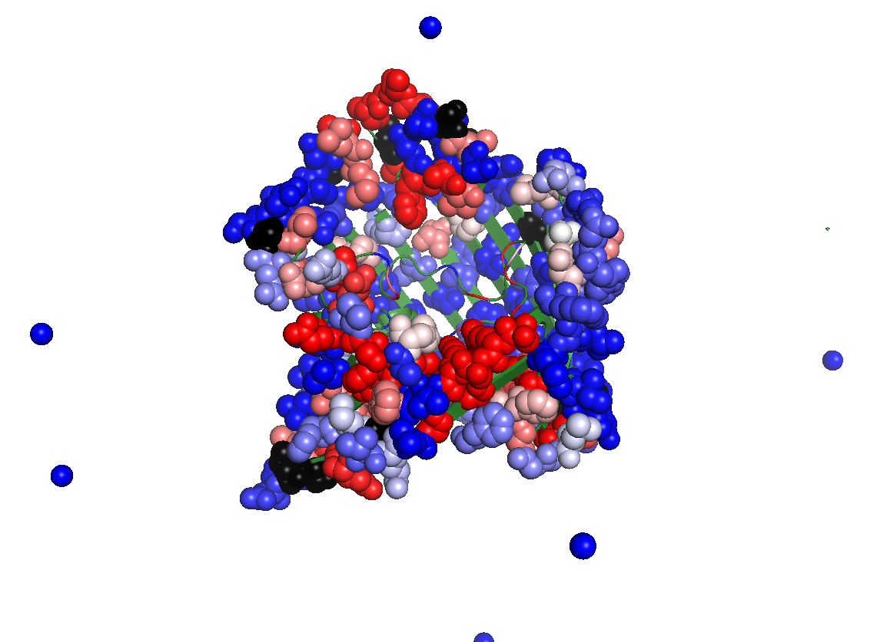

This is the L2, loop, over here

But over *here*, on this *strand*, you have three outward-facing serines.

There are hydrophilics all around, that are exposed.

## 1A0S

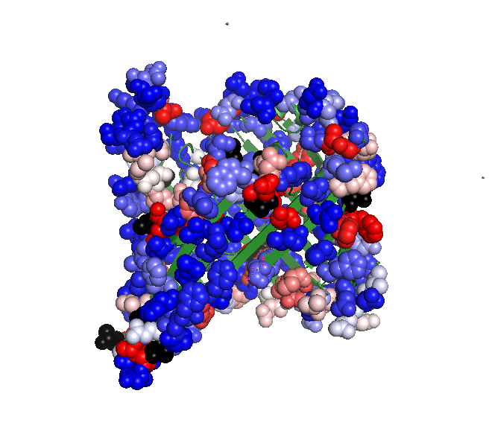

Here's the L2 loop...

And here's one lonely out-ward facing serine. The rest of the high-energy residues are nonpolar, except for that lysine that's marked in the protein science paper. (exclusive moment: >20% SASA and secondary structure is beta sheet)

1E54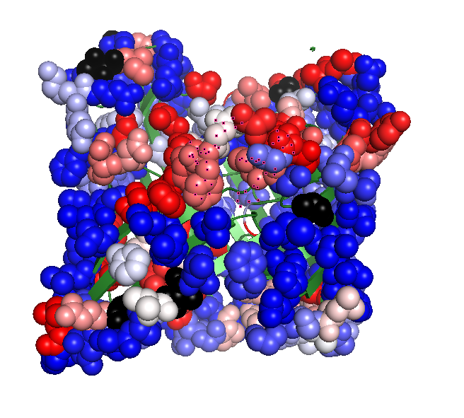

That's the L2 loop, highlighted, there...

And then there's one serine kind of to the left of it, serine 77, with very high energy

And there's this one glutamate near a bunch of aliphatics...

And a high-energy tyrosine actually...

And a bunch of high-energy aliphatics

## 1AF6

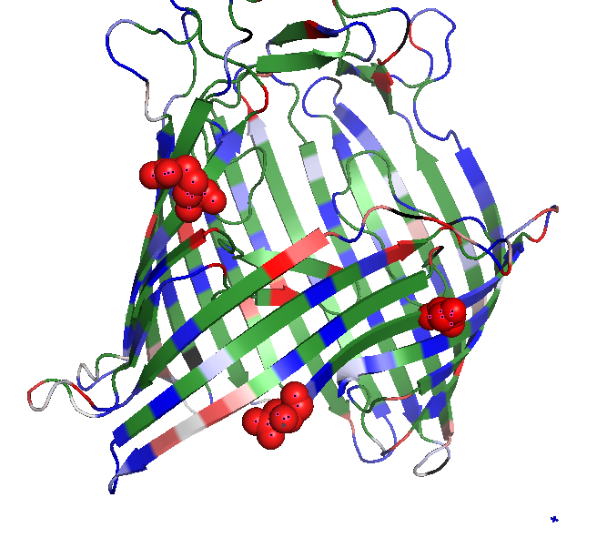

Arg 145, Asp 2, Ser 9, all at the interface

## 2J1NC:\Users\Nanda Lab\Desktop\temp.png

outward-facing high-energy aromatics at the interface: tyrosine and tryptophan.

Down below, there's GLN345, GLU2, and GLU43 on the bottom there. But this protein has high-energy polar residues on the strands in around that area, all around the bottom of the protein. And those three residues don't even have much change in burial upon oligomerization.

## 3PRN

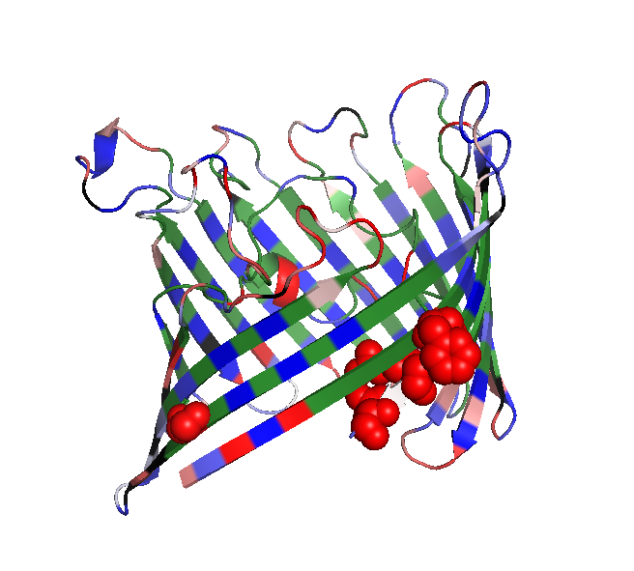

High energy serine on the left there, high energy phenylalanine on the right. So the *polars* are just that serine, and those inward-facing residues on the bottom, which are an arginine (286) and an aspartate (288).